**Assignment: Conjoint Analysis**

**By Fangling Zhang**

Firstly, for each kind of theatre, I average the rate of all responses. Then I split each theatre’s text to 3 attributes (In excel, click data>text to columns). The screenshot of splitting is as follows:

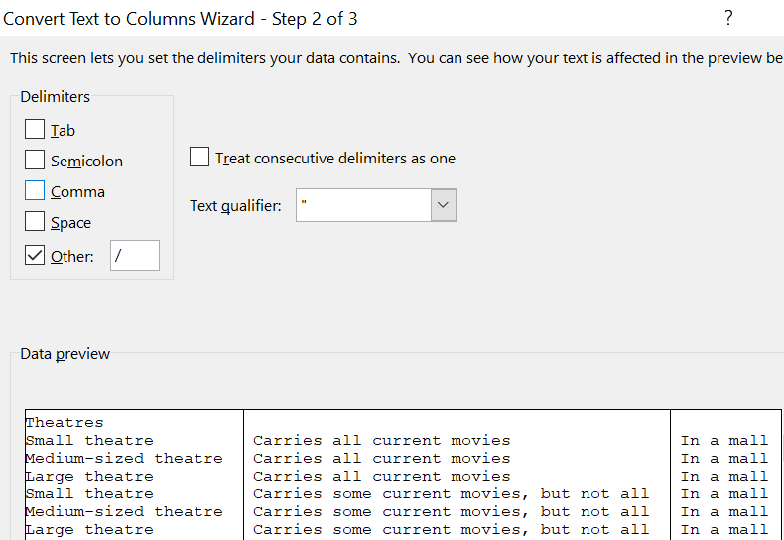

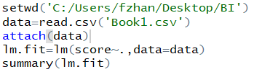Next, I save split value and rates into a new csv file. Then I use R language to perform regression. The code is as follows:

Just for practice, I also generated all possible combinations of 0-1 in excel (use function ‘DEC2BIN’ > use function ‘MID’ > delete sum of same attribute larger than 2, get 27 combinations). Actually this process can be done automatically in R, so here just practice my excel skill. The results is like this:

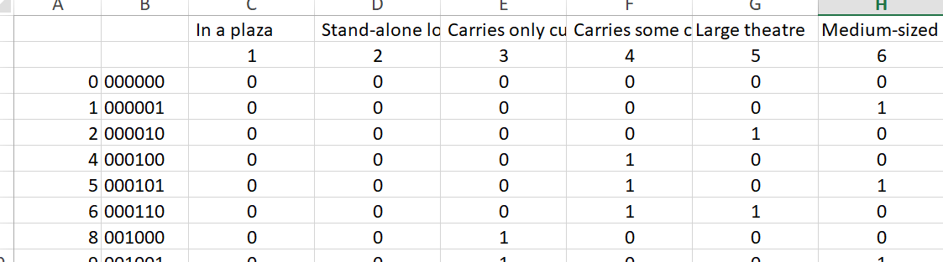

The regression results is like this

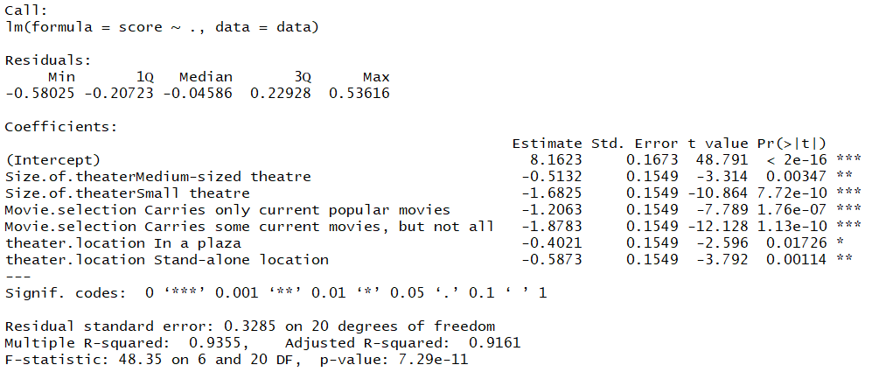

1. To what extent each attribute is important to the respondents? Explain.

Every attribute is significantly important to respondents as the p-value is small enough. The Size of theater can affect respondents from 0 to 1.6825 as the smallest coefficient of this attribute is -1.6825. Similarly, the extent of ‘Movie selection carries’ is important to the respondents is 0 to 1.8783. The extent of theater location is 0 to 0.5873. Overall, ‘size’ and ‘movie selection carries’ are more important than ‘location’ according to the coefficient range.

2. For each attribute, which levels/values do the respondents prefer the most and the least? Explain.

For ‘size of theater’, respondents prefer large size most and small size least. The reason is small and medium theatres got negative coefficients and small size coefficient is minimum.

For ‘movie selection carries’, respondents prefer ‘Carries all current movies’ most because other two levels got negative coefficients. Respondents prefer ‘Carries some current movies, but not all’ least as its coefficient is minimum.

For ‘theater location’, respondents prefer ‘In a mall’ most because other two levels got negative coefficients. Respondents prefer ‘Stand-alone location’ least as its coefficient is minimum.

3. What are the managerial implications of these results? In other words, what actions would you recommend the manager of Hyrule Cinemas to take to improve their business performance?

As ‘movie selection carries’ affect score most, manager of Hyrule Cinemas should firstly change their current theaters to carry all current movies. Secondly, manager should enlarge their current theater. Lastly, as customers prefer large size, Carries all current movies and in a mall theater most, the manager should use these characters if they want to open new theaters.